Monday Musing: April 13, 2026.
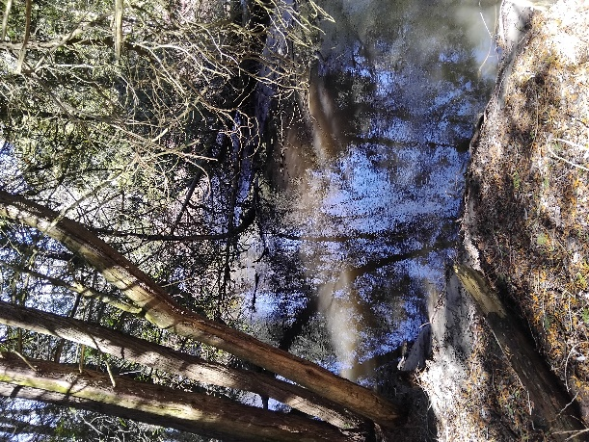
Tired…

Last week Karen and I made an observation about the world and our lives. Whereas at the farm, or the start of our hikes, we would talk about our concerns for the world, home and family, and the occasional rant or two, it seemed to us that our ‘talks’ are longer and heavier. We talk about politics and the economy, the health of our family members, the rust on our cars and gas prices, but for this last while, there has been a heavy cloud of worry. This, we believe, is making us tired. And others too.

Over this last while, maybe since Christmas, I have been hearing people talk about being tired. I have heard it from my parents, kids, friends, and strangers in the food store! I’ve heard it shared at the church too. It has felt, at times, like an epidemic, a large outbreak of unrest and worry.

Last week I thought about this tiredness. I think there are three major ways we can be tired: body, mind and spirit (just to stick with the idea of being made in God’s relational image!). And I mean tiredness relating to everyday life, not an illness.

When we push ourselves to get things done, perhaps within tight deadlines, with piles of stress, doing this and that, it is a very different physical, body stress than hiking in the forest. Physical tiredness requires rest to recover. Sleep. Bath. Massage. Rest. Hopefully, we pay attention to our bodies telling us to slow down and rest for a bit.

Our minds get tired too. When thinking too much, too long, on too many things, we can notice signs of our minds being tired. I tell Karen there’s too much on my brain shelf and it is squished and some things keep falling off – code for forgetting – because there’s just no more room. Mental fatigue requires rest. Silence. Meditation. Music.
And hopefully, we pay attention to our minds telling us to clear the shelf for a bit.

Our spirits can become tired too. We can become weary in our spirits. When we keep giving, worrying, caring, extending, absorbing, sympathizing, empathizing, we can become worn, tired in our spirits. Our emotions often become loose too. And our minds end up with too much on the shelf, and our muscles, tighten up ready to pounce! Spiritual tiredness requires rest: letting go, relinquishing fear, accepting some things are not in our control. Maybe even have a good cry to release the healing property of tears.

Spiritual tiredness. Mental tiredness. Physical tiredness. Each one affects the others. Over extending one puts stress on the other two. And right now, for this last number of months, I believe the state of our world, uncertainty, chaos, unpredictability, massive change from the way things were, has created a layer of stress on our everyday living, that has impacted the wellness of our bodies, minds and spirits. We are very tired.

I believe the ancients have wisdom for this weariness. Turning to the psalms, the prayerbook of the Jewish synagogue and the Christian church, we can hear the prayers of those who lived through uncertainties, chaos and change in their time and place in the world. And Jesus, after learning of the death of John the Baptist, seeing and feeding the five thousand, he told the disciples to get a boat and go to the other side of the lake, while he dismissed the crowds. He then went up the mountain to be alone, to pray, to rest, to be held in God’s love. I believe he was physically, mentally, spiritually tired.

In the church, from September through to Easter, we are busy, physically, mentally and spiritually. Now we are in the time of celebration, the Great Fifty Days of Easter, that lead us to summer rest, renewal, peace. And sleep. Sleep is a large part of our healing.
We’ve heard we need about 8 hours of sleep, on average, throughout our lives. That is one third of every day. Altogether, on average, that is one third of our lives. Sleep must be pretty darn important for the body, mind and spirit.

Prayer

God of Rest and Peace, God of Healing and Renewal, God of Sleep, for our bodies, our minds and our spirits, may we find rest and peace, healing and renewal. May we sleep in the palm of your hand. May we know wholeness when we wake from our sleeps. Amen.

Scripture This Week

Acts 2:14 – 41 Three thousand new followers of the Way of Jesus.
Psalm 116 How can I repay you God?
I Peter 1:17-23 Souls purified through obedience.
Luke 24:13-35 Jesus’ appearance on the road to Emmaus.

TR Question (theological reflection)

We remember dreams when we awaken at certain times in our sleep cycles. What do you think happens in the dreams we don’t remember? How, or do you believe God speaks to us through our dreams? Or is it something else to do with being human?

As we descend from the heavy work of the year towards the summer, may we make plans for rest, renewal, peace, and sleep,

Rev. Dr. Deb Foster, Minister at St. Andrew’s United Church, Markham, 905-294-0351, minister@standrewsmarkham.com

