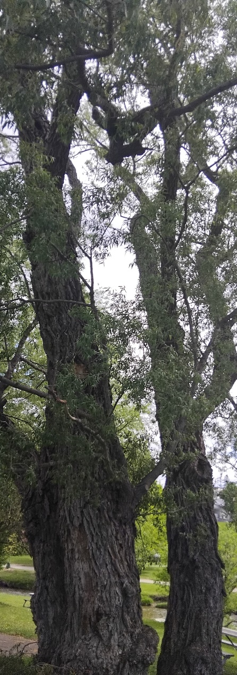
Monday Musing: June 29, 2026
Wisdom…

When in the forest, Karen and I always seem to come upon a gathering of really old trees. Their trunks are marred with scars. Their bark is rugged, toughened through the years of time. We can feel the crevices, rough and jagged, under our hands. And we wonder: If these trees could speak, what would they share with us? What wisdom would they offer, learned through years of being here? What have they seen, heard, felt? We can learn a lot from the trees about the forest, the years, the weather, wars even, and there is much also that we can’t possibly know.

If only the trees could speak.

Wisdom is such a precarious thing. It is essentially the ability to accumulate and organize, use and share, the knowledge and understanding gained through life experiences. To have knowledge is to gather information. To have wisdom is to know how to apply the knowledge to the complexities of life and, hopefully, to better life for the self and others.

Wisdom is that which needs to be shared beyond the sharing of knowledge.

Our bibles are filled with the wisdom of the ancients out of their time, place and experiences of life. By way of stories, legends, prayers, poems, and songs, wisdom is shared. There is wisdom on how to treat your children, especially twins, that comes out of the stories in Genesis. There is wisdom about life told through the writer of Ecclesiastes, even if he is a bit blunt. There is wisdom in the Book of Proverbs, many of which we have heard and don’t even realize where the words come from.

The wisdom literature in the bible is primarily known through Job, Proverbs, Ecclesiastes, the Song of Songs and the Psalms, with the Wisdom of Solomon and Sirach for Catholics and Orthodox Christians. The wisdom literature of the ancients invites and conveys the meaning of human existence, suffering and morality, with knowledge of and experience of God and God’s teachings. Lady Wisdom is a powerful figure in the Book of Proverbs. She personifies God’s wisdom as a woman who offers guidance on life, wealth, and even how to find or know a noble woman or wife. Lady Wisdom is speaking in Proverbs to youth and is the gift of wisdom given to humanity by God. Lady Folly is loud, selfish and seductive leading young men astray. Sophia is the Greek word for wisdom and chokmah is the Hebrew word. In the Christian scriptures, Jesus is known as wisdom in that Christ is the embodiment and ultimate source of divine wisdom.

Wisdom shared, whether from the Hebrew Scriptures or the Christian Scriptures, must be wisdom in conversation, in discernment with the present, because even wisdom is contextual. The wisdom of the trees, if they could speak, would be wisdom gained out of their experiences in their time and place in the forest. The wisdom of our scriptures is wisdom gained out of the knowledge of their time and place in the world.

Some wisdom is eternal. Some wisdom is that which changes as knowledge grows.

Prayer

Holy Wisdom, speak to our hearts,
Message our minds, touch our souls,
Be relevant to us now, out of the past,
For the present and the future.
With what is truly eternal and unchanging,
As the need for justice and peace,
With what is truly contextual and evolving,
As the move from hatred and discrimination,
May this wisdom speak and may we hear and listen. Amen.

Scripture this Week

Genesis 24:34-67 Rebekah welcomes Isaac as her husband.
Psalm 45 A song for the anointed ruler.
Song of Solomon A love song.
Romans 7:15-25a Why do I not do the good I want to do?
Matthew 11:16-30 My yoke is easy; my burden is light.

TR Question (theological reflection)

What wisdom do you hold concerning God that you cherish?
What wisdom will you share and pass on to the next generations regarding your faith?

May the summer breezes cool your body, may the sunsets rest your minds,
May the wisdom of kindness touch your spirit and grant you peace,

Rev. Dr. Deb Foster, Minister at St. Andrew’s United in Markham
905-294-0351 minister@standrewsmarkham.com

