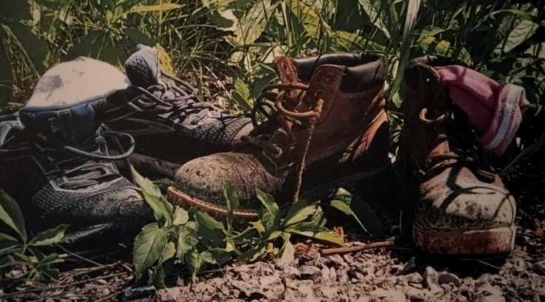
Monday Musing: May 25, 2026.
The Core…

For Karen, and for me, our hikes on Fridays have formed the core of our friendship ever since the farm closed in October 2020. When Norman died, and the animals were dispersed to new homes, and the farm was sold, we were feeling an awful lot of grief. I had spent my Fridays on the farm for 5 years, Karen for 4. Now what? There was so much we were missing. We needed to spend our grief, and our sadness, and recreate the core of our weeks – Fridays. So, we began to walk, to hike, to discover trails across Durham and York, Port Hope, Cobourg and up to Algonquin. We have walked, talked, cried, laughed, eaten, been eaten, and healed through the last 5 plus years. The core of each week became hiking on Fridays, that grounds us for another week no matter what is to happen. Fridays, forests, friendship, this trinity of a sort, has kept us steady and able to respond to the unexpected things in life, as we have driven around, moved through trees, climbed hills, trucked around lakes, up and down rivers, through sun, rain and storms, in nature and in life too. Our core moves.

Recently, I was reading an article in ‘Popular Mechanics’ titled “The Earth’s Core Leaking Gold.” Now of course it isn’t leaking gold. That’s just the headline to draw you in. But there is a nugget of truth about finding of traces of precious minerals moving from the earth’s core into the mantle. The article said that the mantle has less of a platinum group metal called ruthenium or Ru. Scientists have discovered traces of Ru while studying the samples of volcanic rocks from Hawaii. They have concluded these traces of Ru must have originated from the core. They have now also detected markers that indicate Ru did come from the molten core. So…this means that the earth’s core is not as isolated as they previously had thought. They can now prove that huge volumes of super-heated mantle material actually originated at the core-mantle boundary and have risen to the earth’s surface to form ocean islands like Hawaii. Sweet. The scientists say this opens up a whole new way of understanding the evolution of the inner dynamics of our planet. Fascinating.

Just to clarify, the core is intensely hot, dense, and is mostly composed of an iron-nickel alloy in layers. This is called the inner core and it drives our planet’s magnetic field and geological activity (so says Google). Around this inner core is a fluid layer, the outer core, that is liquid, with temperatures between 4,000 and 6,000 Celsius. As the earth spins, the movement of this hot liquid metal creates electric currents that make that magnetic field. Next, the mantle of the earth is a dense, mostly solid layer of rock between the planet’s core and its thin outer crust. The article said the mantle makes up most of our planet; 84 percent of the earth’s volume is the mantle. The mantle provides convection currents from the superheated rock that drives plate tectonics, that is, the continental drift you learned about in high school. The crust of the earth is the thin, solid outermost shell of our planet. It is made of massive moving pieces, the plates of the earth. That is where life lives. That is where we walk, where we are grounded.

One of my favourite movies is ‘The Core.’ It is about some scientists who go to the centre of the earth to re-boot the planet because the core has stopped rotating. The earth’s electromagnetic field is deteriorating and soon the earth will be destroyed. Well, of course they save the day, and the planet. In school, I never learned all this detail of the earth’s inner workings. Nor did I ever learn much about the bible. But we should.

At the core of the bible, is God’s message of how we are to live. This message is shared through the moving stories of families, in psalms and songs, prayers and saga. But over the last few hundred years, we have made a solid mantle around that message. We either never read the bible or we read it so literally we miss the message altogether. The crust, where the feet of our thoughts touch the bible, is our ever-changing context through the centuries. I believe we need to reboot our core. We need to learn, not just the stories, but the evolution of the bible itself through time just like the evolution of the earth. If we don’t then just maybe we’ll stop rotating around the essential message to love one another and we will miss the nuggets of truth that come to the surface.

Prayer

Holy God, of the universe, the galaxies, the earth and its core, in many ways your message of how to live has been given to us, through the moving tectonic plates of earth’s faith traditions. Guide us to revisit, reboot, the grounding rules of harmony, of compassion, of love. May we read and discover the nuggets of precious wisdom that rise from the core through the mantle of our knowing, that the crust of our living might be in peace. Amen.

Scripture this Week

Genesis 1:1-2:4a The first story of Creation.
Psalm 8 What are human beings that God cares about them?
2 Corinth 13:11-13 Agree with one another and live in peace.
Matt 28:16-20 Go and be disciples in the world.

TR Question (theological reflection)

When do you read the bible? How well do you know it, understand it, and its core?

May we continue to learn about the natural world, may we also continue to learn about the world of our faith, Rev. Dr. Deb Foster, Minister at St. Andrew’s United in Markham 905-294-0351 minister@standrewsmarkham.com

