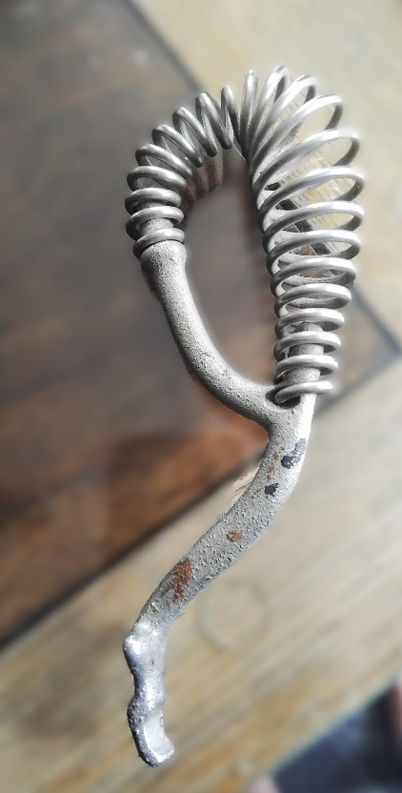
Monday Musing: May 4th 2026.
Memories…

First let me say, “May the Fourth be with You!” that is, May the Force be with you!!!! Those are the words of a text I just received from a gentleman at my church two back. He always blessed us with “May the Fourth,” as the Star Wars’ day of the Force!!! We share this every year, and it rekindles such sweet memories of a really lovely man. But he has nothing to do with the picture. The item in the picture brought back a flood of memories of my Nan. Do you know what the item is?

On Saturday, Elaine and I went to my church’s Indoor Garage Sale. This was on one of the tables. Mimi had donated it. I knew when I saw it that this resided somewhere in my memories, but differently. When Elaine said it was the burner lifter for the old wood stoves, I knew it right away.

At my grandparent’s cottage, they had a wood stove. Nan would lift out the burner covers on the top of the stove with this tool and let me see the fire inside, even put in strips of newspaper to feed the fire. Sometimes, she would let me see into the fire, or making the fire, through the front door through which she loaded the cut-up wood that was piled in a box not too far from the stove on the right. Otherwise, we, the grandkids, weren’t allowed anywhere near the wood stove because it got so hot. Nan’s burner lifter was black, without the coiled handle, but just as heavy. I can feel it now in my hand.

Nan died in 1989. Wow, that’s 37 years ago. She was 69. My memories don’t feel that old but then maybe they do. I remember walking with Nan to the lake, sitting with her on the dock with our feet hanging into the water. I remember worm hunting with her late at night and early in the morning, collecting worms into a small container for Gramp and Dad to go fishing. I remember her making pies, and popcorn, drinking tea in the dining room where puzzles lay underneath the table cloth for the evenings. She would let me have tea too, and back in their home on Lawlor in Toronto, she would give me the beautiful mauve tea cup and saucer and 2 sugar cubes! We would sit and look at the small white Avon lipstick samples in a big square box, (well it seemed big?) and then she’d let me take a few…or was it one? I remember the way she sat, the way she walked, laughed, crocheted, knit, and spoke. I remember how she would hug me. I remember how she made me feel. I remember taking her snowmobiling and afterwards, inside, her putting a plastic container of warm water in my hands by the fire to take off the chill. I remember her sitting with us around the bonfire, just over from the really big old oak tree where we watched for shooting stars…. Ooh I could go on. I just remember. Such wonderful memories. And it all started with one small item on a table found with a friend.
I have so many memories and so much love to remember too. I really miss her. And yet it has been 37 years since she died. This made me think of the gospel writers and how many years had gone by till they wrote, and what memories and feelings they carried.

The apostle Paul was never a disciple but he had an experience of the Christ, changing his beliefs and he began to tell people beyond Jerusalem, starting churches. We have a few of his letters that come from the 50s or so AD -twenty odd years after Jesus. Mark is mostly believed to be a travelling companion of Peter, who was a disciple. Mark wrote around 68-70 AD during the time of the Jewish Roman War. Matthew wrote around the 80s as did Luke. Matthew has a totally different nativity story from Luke. Luke says there were other stories of Jesus floating around as well. Luke was likely Paul’s travelling companion. John wrote towards perhaps around 90 or 100 AD. He has a totally different story of memories of Jesus and of who Jesus was.

Each of them wrote through the lenses of their memories, 20, 40, 50, 70 odd years after Jesus. They wrote of their memories and of the stories they had heard. They wrote of the love people had experienced through this man Jesus, God’s love. Memories, cherished memories long after the time, still needing to be shared, as I have with you, of Nan.
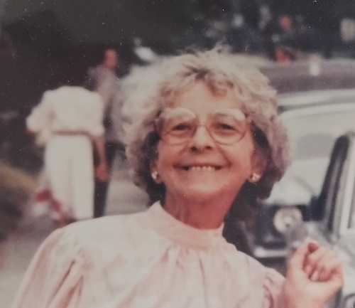
Prayer

Holy God, of what was then, what is now, and of what will be, we hold our memories in our minds, and even when they get altered through time, through foggy forgetfulness of details, we hold the feelings, the love, in our hearts.
By grace, we remember the love – always. Amen.

Scripture this Week

Acts 17:22-31 Paul points the Athenians to the unknown god.
Psalm 66 God preserved us, saved us.
I Peter 3:13-22 Do not repay evil for evil.
John 14:15-21 Jesus promises the Advocate, or Spirit, will be with you.

TR Question (theological reflection)

How is it that love lives on in our memories? How does time affect our remembering?

May your memories of love overpower your memories of grief, may your loves live on in your hearts, with thanks to Elaine, Mimi, Lynda, Genie, Dave, and…Nan,
Rev. Dr. Deb Foster, Minister, St. Andrew’s United in Markham
905-294-0351 minister@standrewsmarkham.com

