Monday Musing: July 6, 2026.
Friends…

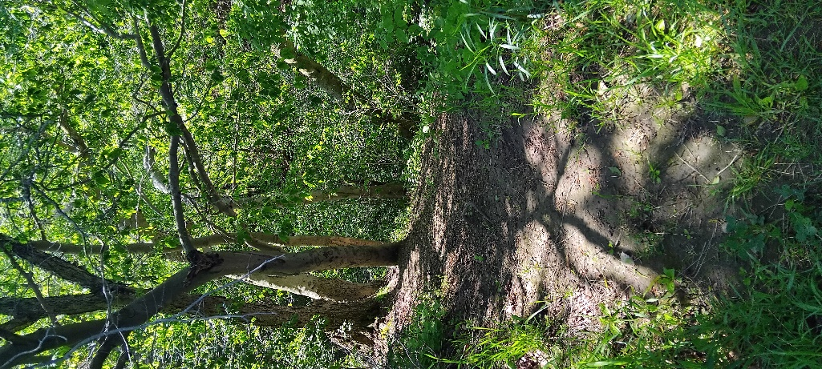
A number of years ago, Karen and I started reading a book about trees. We read how trees form a network, like a family that provides connection and support for each other. I had heard of this before but partly wondered how much of this was just humans anthropomorphizing trees. Yet, Karen and I hug trees and I’ve written how we sense their breath and heartbeat. I have wondered what trees have seen through the years. If only they could talk and share with us? Hmmm…anthropomorphizing.

As a kid, I had learned that older trees are just older trees that must die, fall and decay in order for younger trees to have room, nutrients, and sunlight to grow. You know, the circle of life. I never learned of them being in conversation with each other. Though, Karen and I have wondered whether older trees protect younger trees, standing over them as a barrier to the harsh weather…and humans. We have wondered if they are like parents to each other? Do trees make friends with other trees? What would that mean?

I recently saw a movie that is one of the best movies I’ve ever seen. It was about friends, about humility, caring, courage, sacrifice, morality and ethics too. The man in the movie makes friends with an ‘other’ who is very different. As much as I’m so disappointed with humanity lately, this movie gave me hope. The movie was ‘Hail Mary.’ It has nothing to do with church or Mary. It has everything to do with faith, that is, the faith in a friend and what friends are willing to do for each other.

People do give for others all the time. There are those who work in humanitarian efforts offering their skills to help other human beings, like Doctors without Borders, or Habitat for Humanity. There are those who give of themselves, that is their resources, by sending money to feed strangers, fellow human beings. There are those who will push someone away from an oncoming bus, putting themselves at risk. Caring, courage, sacrifice. Love for others. For how many? The movie asks us to ponder how willing we are to sacrifice ourselves for the lives of others?

Yet being friends is a bit different, isn’t it? Friends share a deep connection, a sharing of words, thoughts, time, meals, walks, and help when life gets rough. The deepest friendship is one in which we will give of ourselves that our friend(s) might live more fully, grow and find themselves when they feel lost, and know they are never alone. Sometimes that is giving space; sometimes that is opening arms with the gift of a hug that does not end till both are ready to let go. That’s a hug of love.

The greatest gift of love is the gift of yourself, the gift of understanding and presence, in silence or in sharing. It is the gift of being there through whatever storm is pounding hail stones on us. Storms aren’t just from nature. The forests know this. Humans can be wicked torrential storms wreaking havoc on each other and on the earth. Humans also have the ability to offer strength, shade, protection, compassion and help. Faith, hope and love. And the greatest of these is love. Friends know what it is to let go of all else, even life itself, for each other, because of love.

Years ago, my Dad said to have many friends in life, to keep them close, because one day “you’re really going to need them.” As I’ve grown older, and my world become larger, I have come to know how precious and wise Dad’s words were and still are.

May you have lots of friends, may you keep them close and may they keep you close.
May you offer to each other the love for the journey you travel together. May you offer to each other hugs that don’t let go.

Prayer

Gracious God, made in your relational image, we are called into being with and within your creative giving, to be with one another, with you and all of creation, all we call nature, all the world. May we learn that call is to love. Amen.

Scripture this Week

Genesis 25:19-34 The rivalry of Jacob (Israel) and Esau (Edom)
Psalm 119 Meditating on the law of God; a Hebrew acrostic poem.
Romans 8:1-11 Life in the Spirit.
Matthew 13:1-23 Teaching in parables of the Kingdom of Heaven.

TR Question (theological reflection)

Who have been your friends through the years? Who are your friends now? Who are your closest friends with whom you share a deep abiding love?

May you always have friends, sharing time, stories, food and hugs. May you have many friends, and keep them close, for one day you will really need them.

With thanks to my friends,
Rev. Dr. Deb Foster, Minister at St. Andrew’s United in Markham
905-294-0351 minister@standrewsmarkham.com

