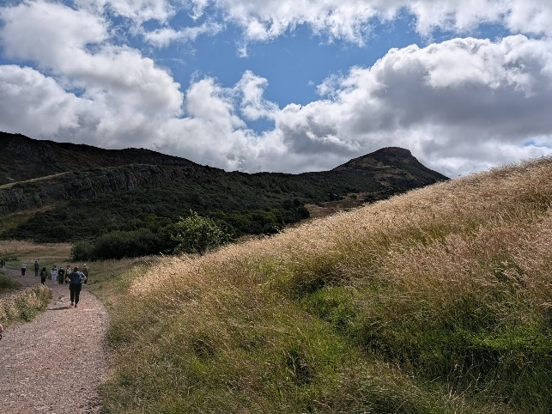
Tuesday’s Thoughts: August 4th, 2026
Limitations…

I’ve just returned from spending some time travelling around Scotland. I especially wanted to see the highlands along with so many other aspects of this beautiful country. And I got to do just that. It was a time of experiencing and learning and reflecting on life and faith. It was a journey into learning about me too.

On the first full day, we went to the award-winning exhibit Dynamic Earth where we got to ‘experience’ creation from the Big Bang onwards. It really is quite something to contemplate how we are made of star dust. Humbling too.

Afterwards, we took to the path to climb to St. Arthur’s Seat high above Edinburgh. It is the site of an ancient volcano and rises 250.5 meters, or 822 feet, above sea level. Our plan was to climb to the top. No problem, right? Many others were doing it. You can see it in the distance in the photo. It was like a pilgrimage, climbing high to see as far as we could see. Our goal was clear, visible, achievable, possible. Until…

I got nearly all the way up. Nearly. But my right knee began to ache with the climbing and my left knee began to stab with any sideways movement. I kept going even as I began to wonder what the trek back down would be like. Very near the top, I had to stop. I had to sit. I had to let the others keep going that last bit without me.

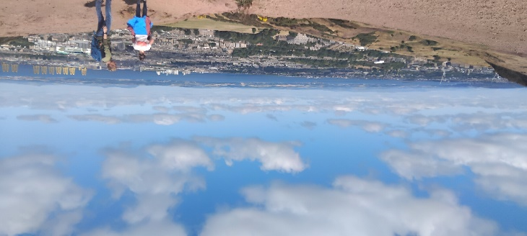
It was within sight. I could hear the winds. I could hear people’s voices. It would be a more difficult climb but no where near as far as I’d already come but…but…it was more of an incline, more slippery with sharper rocks. More dangerous. I knew I could likely make it but what about coming down from there? So, I stopped. I found a place to sit on a rock and look around. It was beautiful as I sat and contemplated my limitations…and my expectations. It sure was hard to accept my need to stop. It sure was hard to let go of my beliefs about my own abilities. Wisdom and fear were somehow woven together thankfully.

As I looked out and so far, I found myself thinking about my body, my mind and spirit here. We are each shaped by our knowledge, skills, abilities, beliefs, wisdom and fears. These things form who we are and our limitations and expectations. Through life we need to accept that these things can change. It is often easier said than done. Sometimes we need to stop and look around.
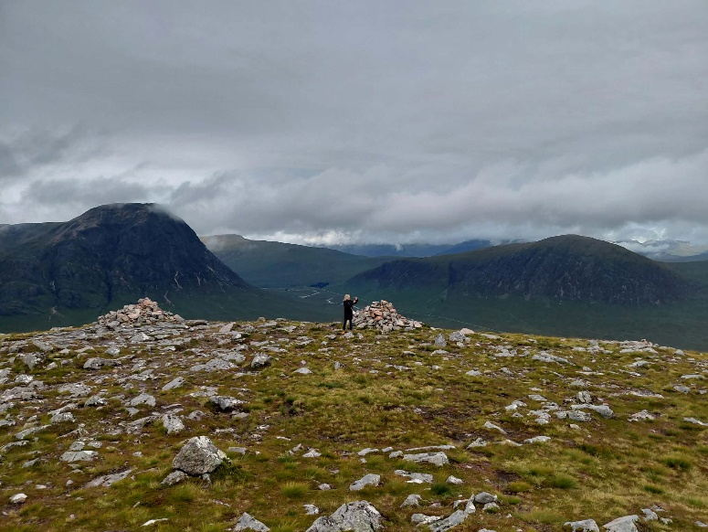
A few days later we climbed another path. Wisdom and fear came with me. I didn’t think I could cross the angled single file metal bridge over the crevice. I did though. I didn’t think I could climb to the summit here. I did though. It was a different climb but one I could do. And the vista was breathtaking. That’s me in this pic. I’m the black dot placing my stone.

Sometimes we really need to reflect on our limitations and our expectations, when, where and why. We need to listen to our body, mind and spirit because we change through time. I saw I didn’t have the agility of the child who was also climbing. But the child didn’t have my stamina. I saw I didn’t have the strength to make that first peak, but I did for the second peak, while passing other seniors who had stopped as their limits were reached.

You know, a church is like one person, with limitations and expectations. Sometimes we need to sit together and reflect upon them. Sometimes we need to challenge them too.

Prayer

Holy One of the mountains, call us up the paths, climb with us to where we can go,
Guide us back down, that the ascents in life open vistas of seeing ourselves. Amen.

Scripture this Week

Genesis 37:1-28 Joseph is sold into servitude by his brothers.
Psalm 105 Remembering Joseph.
Romans 10:5-15 The word is near you, on your lips and in your heart.
Matthew 14:22-23 Jesus walks across stormy waters.

TR Question (theological reflection)

What are your limitations and expectations? How are they shaped by the beliefs of our faith tradition and your faith in the God you know?

May we each know peace in who we were then, who we are now, and in who we will be, Rev. Dr. Deb Foster, Minister of St. Andrew’s United in Markham
905-294-0351 minister@standrewsmarkham.com

