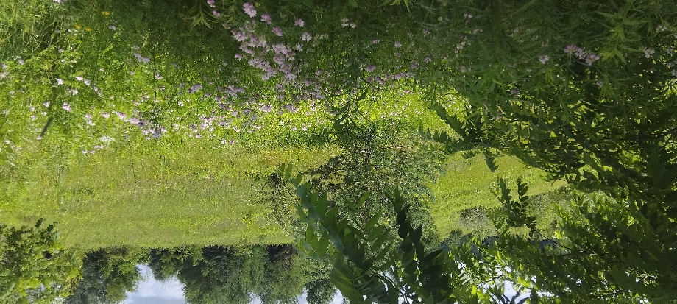
Monday Musing: August 24th, 2026.
Screens…

One of the best things about the forest is the silence that is only broken by the songs of birds, the whispers of the wind in the swaying branches, the chips of chipmunks, and the kuk-kuk of squirrels. And maybe there’s the sound of a stream trickling or a river flowing near to us. Maybe. But there are no beeps, bings, or bells of any sort connected to computers, cell phones, printers, or tablets, no notifications, and no screens. None at all. What we see and experience is the view of our eyes, the lens of our hearts and minds, and the silent rest of our souls.

One of the things we noticed in Scotland was the lack of screens. Not only were there hardly any fast-food, restaurant or coffee shop chains as we have in North America, when we did go into a restaurant or coffee shop, or bar or tavern, there were hardly any screens. People were speaking with one another. They were laughing and chatting and so animated in their conversations. There weren’t a lot of cell phones out either.

We are so inundated by screens. Just think, they’re everywhere here. They are in convenience stores and walk-in pizza places, restaurants and bars, sometimes even at your table. They are in your doctors’ offices, dentists’ offices and more. Small screens, large screens, gigantic screens like at Dundas Square, we are overrun by screens and we are conditioned to turn our attention, turn our eyes, and turn our heads to them wherever we go. They’re in our homes as computers and televisions, with high resolution to make everything ever crisper, and as we enter a room, our eyes turn to the screens instead of to people. I’ve noticed the difference in the sounds of conversations here with all our screens compared to the sounds in Scotland. What do you notice?

Churches began using screens decades ago and increasingly so over the years. It has been believed better to have everyone individually looking up, projecting forward, reading the prayers on the screens, reading the lyrics on the screens, reading the announcements sometimes – on the screens. We haven’t stood and sang sharing a hymn book with our neighbour in years. Well, unless it is what I call a ‘retro Sunday’ when the power is out or the technology has failed us. Yet, look what happened during COVID.

During the pandemic we learned to use Zoom, Facetime, Jitsi and Teams, to connect families and churches through screens, and screen sharing, bringing Sunday services, group meetings and chats into our homes, onto our screens, keeping us safe. This has all been so beneficial to keep us connected and for staying connected with those who can’t physically get to church to stand and read and sing with us there from the screens. Many people learned to use the technology that put us on screens, sometimes like Hollywood Squares, in our homes individually but technologically together.

Did we lose something though? Maybe without screens in our doctors’ and dentists’ offices, restaurants and stores, we would otherwise be sitting in silence. Or would we talk to each other? I don’t know. But I do know how important it is to be human with one another, in relationship with each other, eye to eye, smile to smile, voice to voice, even tree to me. I’m sure you can imagine how focused I am now on observing people and screens wherever I go, and how often I too automatically look for the screens.

Prayer

Holy One, as our world continues to change, becoming more wired and connected,
As technology presents notifications and links, QR codes, apps, beeps, bings and bells
To get our attention, to lure us to screens, to respond immediately,
May we not forget what it is to hear the human voice,
The human cry, through our human eyes and hearts.
May the images on the screens not desensitize us
to the real tragedies and suffering in the world.
May we not forget what it is to be human, to feel and to touch.
May our faces not become expressionless screens.
May our views be deep and wide, may we see the natural sacred world,
May we see through the lens of our hearts. Amen.

Scripture This Week

Exodus 3:1-15 Moses encounters the burning bush.
Psalm 105 Remembering Jacob and Moses
Romans 12:9-21 Let love be genuine; overcome evil with good.
Matthew 16:21-28 Take up the cross and follow me.

TR Question (theological reflection)

What is the cross you and the church are invited/called to pick up now?

As we move through these last weeks of August and into the fall, may we lift our eyes away from the screens to see the beauty of the changing world around us. May you know peace in your hearts because of the beauty you see,

Rev. Dr. Deb Foster, Minister at St. Andrew’s United in Markham
905-294-0351 minister@standrewsmarkham.com

